- A measure of central tendency
  - Mean
  - Median
  - Mode

A measure of central tendency:
There are three main measures of central tendency: the mode, the median, and the mean. Each of these measures describes a different indication of the typical or central value in the distribution.
Mean: find out the Average of the data
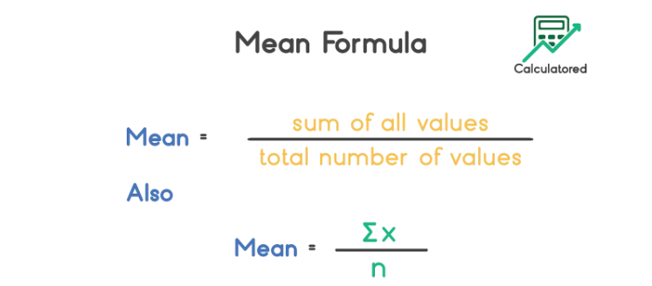

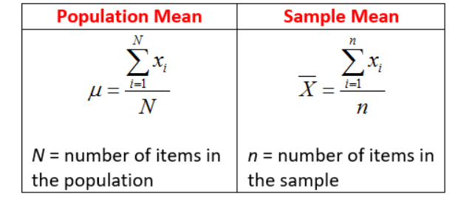
Median:
Median for Even:
If the Number of elements are even the find the average of the central elements.
Ex [1,2,3,4,5,6,8,100,120]
Median for Even
=5+6/2
=11/2
=5.6
Median for Odd:
If the Number of elements are odd then find the average of the central element.
Ex [1,2,3,4,5,6,8,9,100,120]
We can directly take the central element as the final value for the Median which is 5 in this case.
Mode:
Mode is the most frequently occurring element.
Example1:
{2,2,2,3,4,4,5,5,5}
2 and 5 is a mode for the above case
Example1:
{2,2,2,3,4,4,5,5,7,8,8}
2 is the mode in this case since 2 is occurring most of the time.

